[**Web Development Overview**](https://www.youtube.com/watch?v=erEgovG9WBs)

1. **Introduction to Internet and WebDev**

- Internet Protocal Suite, is a standardized way the computers communicate.

- IP (Internet Protocol) is used to identify each computer on a network

- Computers can transmit information back and forth using TCP (Transmisison Control Protocol). It breaks data into packages and transmit through hardwares like modems or cables.

- The Internet is like a **hardware**. Instead, the Web is the **software** that sits on the Internet, where people can access web pages through HTTP (Hypertext Transfer Protocol).

- What’s special about it is that it gives every webpages and content a URL (Uniformed Resource Locator).

- The Browser is called a Client, because it’s consuming information. But on the other end of the URL, there’s another computer called the Server. It receives HTTP request from the client, then send a response containing the webpage content.

- Every webpages have a unique Domain Name. A domain name can be registered by anyone via Registrar (Google Domain).

- When you navigate to a domain in the browser, it gets routed to the DNS (Domain Name System), that maps these name to an actual IP address on a server somewhere 🡪 DNS is like a phonebook of the Internet.

**Domain Name vs URL:

The URL contains the Domain Name (or more specifically, Fully Required Domain Name).

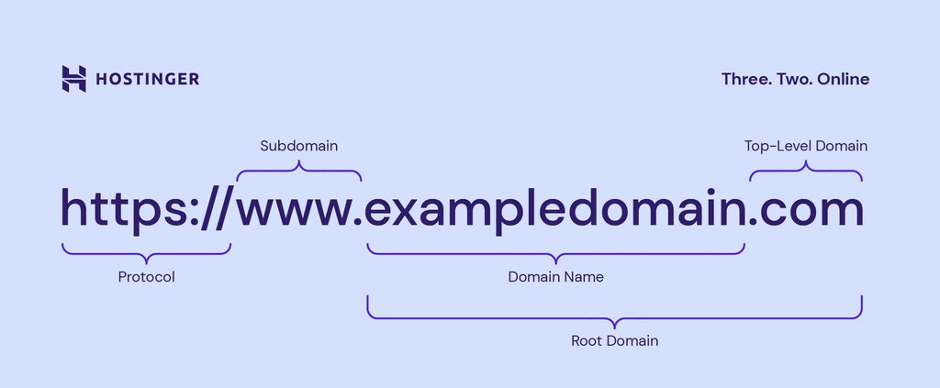

1. **Frontend**
2. **HTML**

HTML creates, or renders, the elements onto the screen. HTML elements are nested together in a hierarchy to form the DOM (Document Object Model)

1. **CSS**

CSS helps with the styling of those elements, along with **creating layout, positioning** (more difficult) and **responsive layout** (works for different devices)

🡪 Basically, we can create a website only using HTML and CSS.

1. **JavaScript in HTML**

However, we want to make our website more interactive with users. We may want features like button clicking, elements moving with the mouse, etc. This is when we need JavaScript.

** To run JavaScript on a webpage, we run it in a separate file, then reference as the source in the <script> tag in HTML.

Normally, we want these scripts to run after DOM has been set (the main body of the HTML file, because we want the elements to appear first). This is why we use the defer attribute in the <script> tag.

The most common reason why we need JavaScript is that we want to **handle events**. Whenever the user does something on the webpage, the browser listen to these events. In our JS code, we will then do things like (document.querySelector) 🡪 Mostly work with objects.

1. **Frontend frameworks**

However, most developers do not want to work with these prototypes and low-level languages 🡪 instead work with frontend **frameworks**, e.g., React.js, Vim, Angular.

These frameworks represent the UI as a tree component. Component can encapsulate HTML, CSS, JavaScript into a format that looks like one small object.

More importantly, they describe declarative code that describes what the UI does, which is much easier to work with compared to Imperative code that we create in JavaScript.

1. **Backend**

<https://www.youtube.com/watch?v=erEgovG9WBs>

Node.js